Membership Database System (MbrDB)

Introduction
The Membership Database (MbrDB) has been developed to provide:

- A comprehensive, web based system for management of the supporters of a non-profit organization,
- Implemented using OSF (e.g. license free) software such as PHP, mySQL5, LibreOffice, etc.
- Incorporating the ability to access the system from a PC, tablet or smart phone, and to
- Improve and add business processes for to optimize suppporter community management reminders and follow-ups.

The following paragraphs describe the various functions available.

Member/Contact Classifications
The MbrDB consists of information about various types of supporters each identified by a unique Member/Contact ID (MCID). This MCID consists of 3 characters and 2 digits usually comprised of the first 3 characters of the last name (or organizational name or acronym) and the first two digits of the contact/members street address.

Addition of a new MCID is blocked if it is duplicated in MbrDB. If a proposed MCID duplicates an existing one, a list of unused MCID's are provided to choose from.

It is mandatory that each MCID identify a specific person, family, volunteer or donor. If the MCID is to be used to designate a family membership then the fields for the correspondence salutation coupled with the name label 1st line fields are used to customize how mail and labels should appear. In the case of volunteers, each must have their own unique MCID even if they are a part of a family membership in order to track individual volunteer time and mileage data.

If the MCID is for an organization, legal entity, business, trust, etc. then the organization name should be provided as well as the name of the inside contact for that entity given. If there is no individual name provided, then the supporter record should be considered a 'Donor'.

The MCID is merely a methodology to identify a supporter. A broader search for a name, city or street name is also provided. However, usually the 3 character/2 digit construct is sufficient to provide a unique identifier.

Member/Contact Classification Status Options
MbrDB is a collection of 'supporters' of a non-profit. This collection of supporters is broken into 4 different classifications referred to in the database as a Member Status or 'MemStatus'. This provides the opportunity to uniquely manage each classification differently since each status grouping presents different and unique challenges. The following defines each of these classifications.

Contacts (MemStatus = 0)

- Has not opted to support the non-profit either financially or by volunteering time
- Has incomplete information that should be fully provided before being moved to another category.
- Usually consists of potential members that have been proposed, perhaps, due to expressed interest like doing a rescue of an injured animal.

Recommended actions: contact should be made with the information available to determine level of ongoing interest and in what capacity. Move the classification to 1, 2 or 3 depending on the information obtained.

Members (MemStatus = 1)

- Have chosen to support the non-profit with annual or monthly subscription dues payments.
- Have complete information on record to allow them to be included in periodic mailings and appeal letters. For organizations this information should Includ the individual name or 'inside contact'.
- Have an expectation of receiving periodical information in the form of newsletters and solicitation letters by providing email and/or address information.
- May also make donations in addition to the annual or monthly dues payments.

Recommended actions: make contact via reminders by phoning, email or regular mail to encourage renewal of their annual membership while promoting an increase in the level of support last provided. Use the Correspondence tab or 'Reminders->Send …' to track reminder actions taken.

Volunteers (MemStatus = 2)

- Have chosen to support the non-profit by volunteering their time.
- Are also asked (but may not be required) to pay annual dues.
- Time and mileage is recorded for each volunteer through the volunteer management interface.

Recommended actions: track volunteer annual dues payments and in-kind donations towards membership dues sending reminders of membership dues when needed. Move status to “Member” if no longer an active volunteer.

Donors (MemStatus = 3)

- Have chosen to support the non-profit with funding support such as one time donation payment(s), event sponsorships or purchases, and other financial support usually on an annual basis.
- Have indicated that they are not necessarily interested in receiving newsletters of appeal letters and usually do not EXPECT any benefits of membership such as newsletters, etc.
- Usually are organization, foundations, businesses, corporations, trusts or other legal entities.
- Usually do not have a singular named point of contact but rather an organizational entity (e.g. Office of the President, etc.)

Recommended Actions: periodically check to determine if any solicitation has taken place within the last 12 months and begin an outreach program to ask for their support if not.

Menu Navigation
The main menu of MbrDB is based on the concept of using an 'active' MCID. An individual MCID is made 'active' when it is selected using the 'Lookup' function at the right of the menu bar. The Lookup function uses all or part of any MCID string entered and attempts to find the relevant MCID being requested.
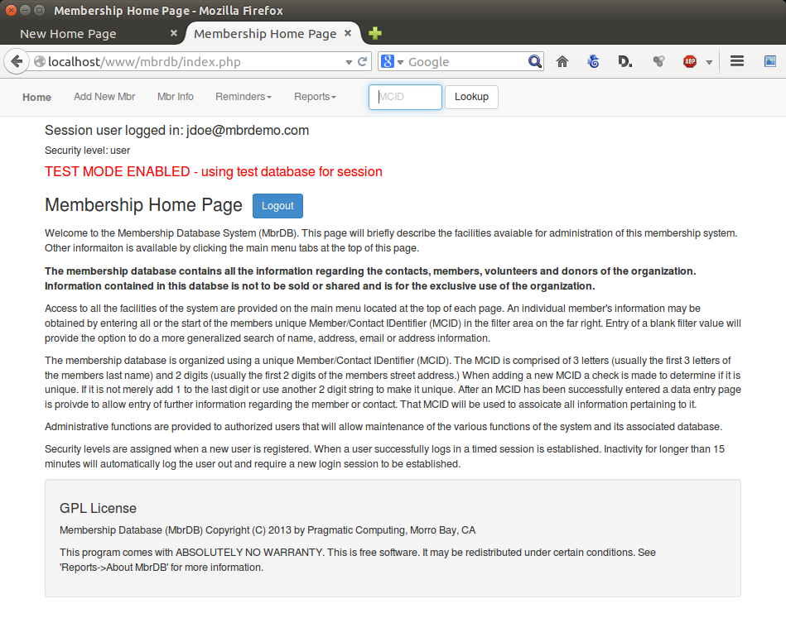
One of three situations can occur when using the Lookup function:

- If the Lookup field is left empty and the Lookup button is clicked a search page is produced allowing the entry of a character string to be entered. This string will be used to examine all records of the database looking in the MCID and all name and address fields for a matching string. A listing of all matches is produced that will allow a single MCID to be selected by clicking the associated radio button on the left of the listing. This selection then becomes the 'active' MCID.
- If a complete 5 character MCID is entered then the individual record for that MCID is displayed and it becomes the 'active' MCID.
- If an incomplete MCID is entered (i.e. the first 3 characters of the MCID – which is usually the first 3 characters of the last name) a listing is produced listing all MCID records that match the string entered. A single MCID may be selected by clicking on the associated radio button on the left of the list. This selection then becomes the 'active' MCID.

Once an 'active' MCID has been selected, the funding and correspondence records associated with that MCID can be displayed using their respective menu tabs in the member info page.

Membership Information
The main menu is presented upon successful login to MbrDB. Use of the system begins with the entry of an MCID in the 'Lookup' field at the right of the menu bar. Until a specific MCID is accessed, each menu item on the main menu will merely provide an explanation of its functionality.

If an full, valid MCID is entered that information will be retrieved from MbrDB and displayed. If a partial MCID is entered, that is the first 1, 2, 3, or 4 characters, the system will use what has been entered and provide a list of those MCID's that contain matching, corresponding characters in their MCID. The following screen shot illustrates this process.

A search for a members record can be done by merely clicking the 'Lookup' button on the end of the main menu item without entering anything into the lookup field. A general search allows for member records to be located by entering a character string into the search field. All records that contain the search string is listed in the result and the specific MCID can be directly accessed by clicking the bullet at the left of corresponding line.

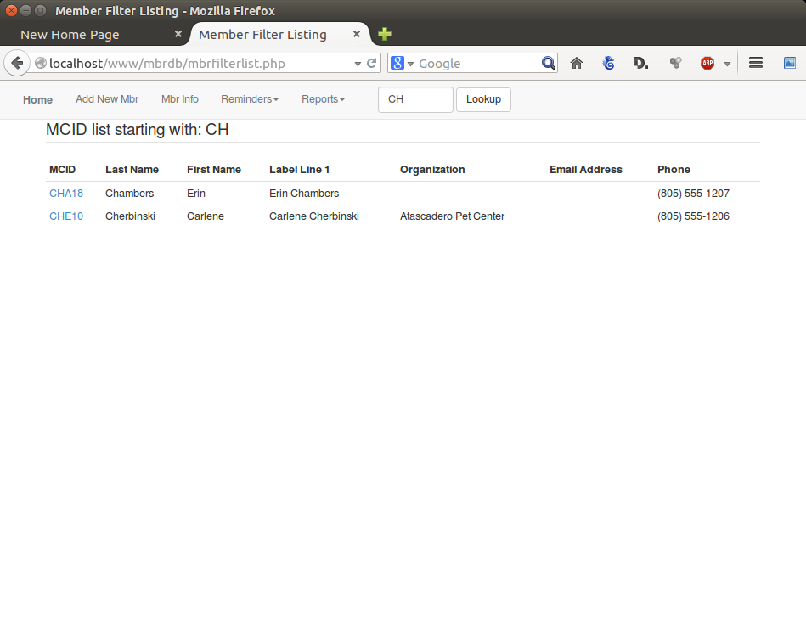
In general, the search string entered should contain no more than 6-8 characters keeping in mind that the more entered will dramatically reduce the number of those that will be selected.

Add New Member

This menu selection provides the ability to add a new membership record to the database. The initial page is used to explain the process and the formulation of the unique Member/Contact IDentifier (MCID). Creation of a member record with a duplicate MCID is blocked. If a proposed MCID is already in use a list of available MCID's using the first 3 characters is provided to choose from.

Once a unique MCID has been specified the record is created and presented for completion and that particular MCID is no longer available for use. Note that certain default fields are preloaded with specific information pertaining to the new record. In particular, the 'Date Joined' field is loaded with the current date to denote when the member was introduced.

MCID Info

This menu item provides provides review and update of a member's information. Selection of a specific member is done by performing a 'Member LOOKUP' as previously explained.
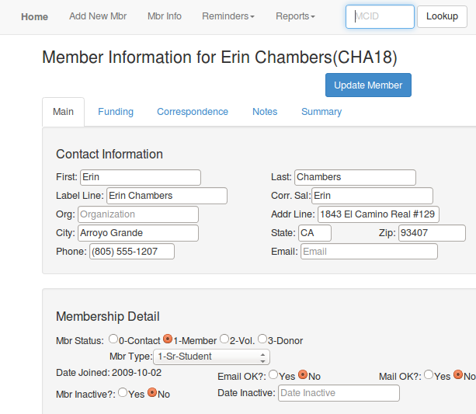
Member
Tabs
The information provided on the main information page provides all information for a member. Some screen edit checks are performed, however, to ensure that information entered and has continuity. For example, if a member is marked as “Inactive” the Date Inactive field is automatically updated with the current date. All changes entered must be made permanent by clicking the 'Update Member' button located either at the top or bottom of the page. Any attempt to select a different menu item after making any changes to the form will cause an alert to be displayed requiring confirmation to abandon those changes.

Tabbed Member Information
Tabs within the member information page denote the availability of additional information regarding the member being displayed.

- Funding – displays the reverse chronological listing of all funding provided by the supporter. To add a new funding record for the member merely click the 'Add New Record' button and complete the form presented. See the following explanation for more details.
- Correspondence – displays a reverse chronological listing of all correspondence records noted when contact with the supporter has been done. This listing will include, amongst other things, notes as to when email, letters and reminders have been initiated. See the following explanation for more details.
- Notes – provides a free form entry area for any special notes regarding this particular supporter.
- Lists – (not shown) IF THE SUPPORTER IS IDENTIFIED AS A VOLUNTEER, this tab is presented to allow a list of defined volunteer mailing lists with check boxes provided to allow subscription to one or more of them.
- Summary – provides a brief summary of the last dates and amounts provided for dues and non-dues support, last correspondence date and type as well as links to allow a general email, an email reminder or a hard copy mail reminder to be created for this supporter.
- Follow Up – provided to allow easy entry of notes and information pertaining to the supporter. Information entered in here will be added as a new correspondence record.

Extended Donor Information (EDI)
If the user id used to log into MbrDB is registered as an 'admin' or 'ediuser', additional menu items will appear immediately to the right of the 'MCID Info' menu. The first is a drop down menu with a selection of actions regarding EDI.
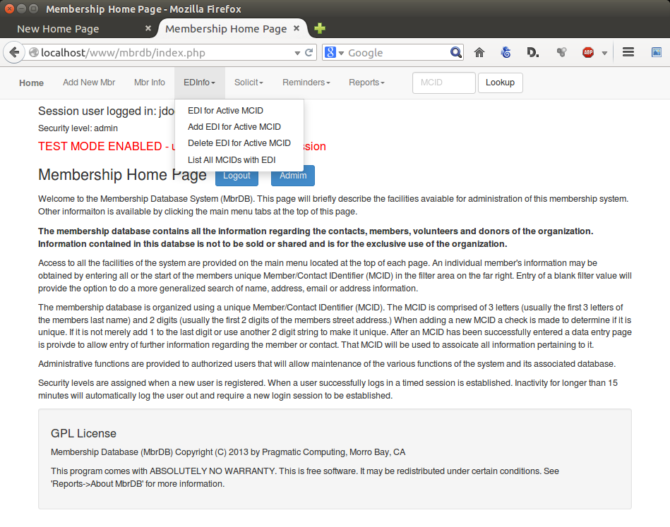
EDI research is usually done to further detailed information regarding a specific donor. This research is usually done to provide the organization with the opportunity to cultivate and engage with the potential donor. This added information should be considered as confidential to the organization and only those authorized by the organization should be able to update and/or view it.

EDI sections are free form in nature allowing the researcher to input data as text. There are 6 section provided with each section initialized with headings usually associated with the section heading. It is left to the researcher to provide the amount and level of detail needed.

EDI for Active MCID

This link will provide access to any EDI data that has been previously entered for the active MCID. This information is broken into various sections and displayed in the ensuing page by clicking the appropriate tab. Updates to new data may be entered into each tab section by clicking the 'UPDATE' button in that section.

It should be noted that the information provided for the MCID is in addition to fields already available for the member. Additional information should provided with appropriate attribution and research. Use the 'Funding' and 'Correspondence' tabs to track donations provided and correspondence contacts with the MCID regardless of whether EDI is provided or not.

Add EDI for Active MCID

Individual MCID's do not automatically have an associated EDI records. An EDI record must be created for any MCID for which additional information is to be provided. Clicking this menu selection will confirm that an EDI record is to be created an perform the necessary actions to create a 'blank' record. The blank record provided has various 'sections' that are created with formatted information provided to prompt the entry of specific information as needed.

Delete EDI for Active MCID

This action will delete the EDI record for the active MCID after a confirmation prompt is acknowledged. Care should be taken as this action is not reversible and data lost can not be retrieved and will have to be re-entered in needed.

List All MCIDs with EDI

This menu link is provided to allow quick access to those MCID records that have associated EDI records associated with them.

NOTE regarding report 'Print Active MCID Info'

A special section of the report titled 'Print Active MCID Info' is added if the user has been provided 'admin' or 'ediuser' authority. This new section displays all the edit information that has been entered for that MCID to provide a comprehensive review of all information pertaining to a member.

Solicit
Solicitation menu functions are highly customized based on the organization. Usually these require the direction of a Development professional to develop the scripts and protocols used in solicitation of funds via telephone or other means. This menu provides items to allow integration of calling scripts, integration of payment systems and other facilities that could be used by a non-profit for funding drives.

Funding
Tracking of payments for the 'active' MCID is done on the “Funding” tab of the Member Info page where past payments may be reviewed and/or edited. A new payment notice may also be added and updated to note new payments or donations.

A screen shot of the funding page for the 'active' MCID is obtained by clicking the 'Funding' tab. As shown, all records that have been entered to record any financial support to the non-profit is listed with the most current at the top. All records may be edited by clicking on the corresponding “EDIT” icon on the left of the line. This is not usually necessary but may be done if more information in available or if specific notes need to be added to that entry.

In the case that the funding provided is financial or in-kind donation a specific “Program” may be identified designating what the payment is for. Additionally a “Campaign” field is provided to allow the payment to be associated with a specific fund raising effort or campaign to allow future evaluations of the efficacy of a specific campaign.

The fields 'Purpose', 'Program' and 'Campaign' are configurable be a user who has been granted administrative access. However, careful consideration should be given to summary reporting that is to be done as some fields might be duplicative.
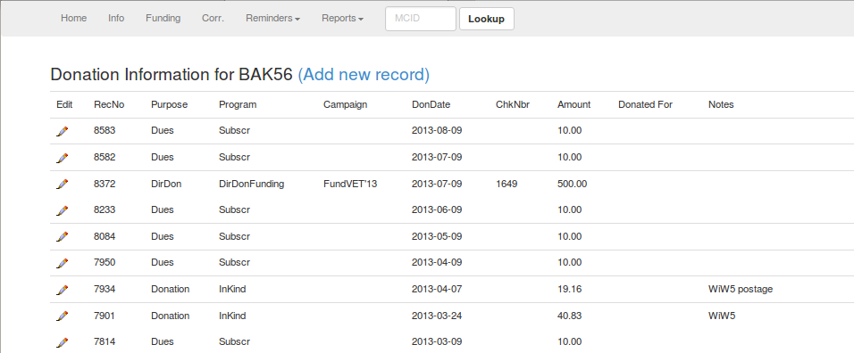
Creation of a new funding record is created by clicking the “Add New Record” link at the top. The new record will be listed at the top of the list. Use the 'EDIT' icon to update the associated record if needed. The following illlustrates the funding listing after 'Add New Record' has been clicked.
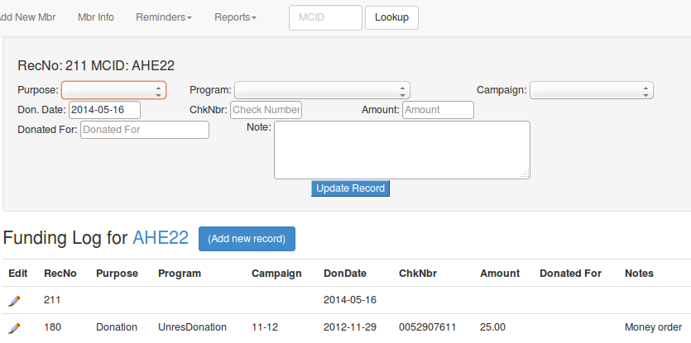
In this example a new record (RecNo 211) has been created for the MCID. The fields 'Purpose', 'Program', 'Don.Date' and 'Amount' are required to be entered from their respective drop down menu selections. There is a specific relationship between the 'Purpose' and 'Program' fields. These fields are used to classify funding records used in various reports.

Correspondence
All communication with the membership is tracked by the entry of 'Correspondence' records. The following screen shot shows the listing of recent correspondence to the 'active' MCID. The latest correspondence is list at the top.

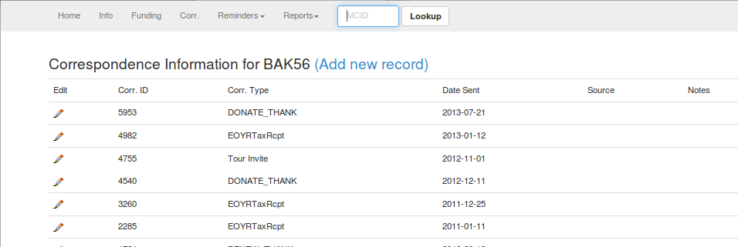
Creation of a new correspondence record is created by clicking the “Add New Record” button at the top. The new record will be listed at the top of the list. Use the 'EDIT' icon to update the associated record if needed.
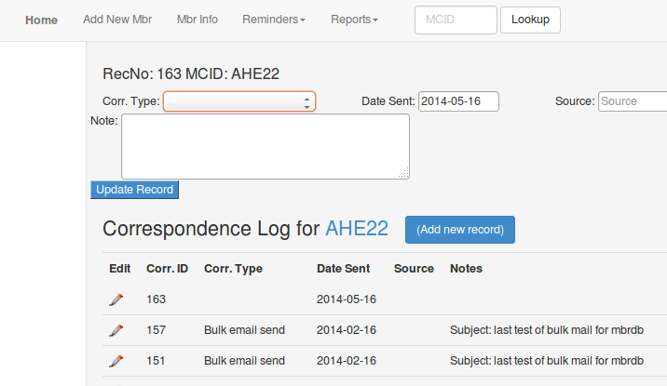

In this example a new record (RecNo 163) has been created for the MCID. The fields 'Correspondence Type' is required to be entered from the drop down menu selections. This field is used to classify correspondence records used in various reports.

Reminders
A business methodology has been implemented into MbrDB to facilitate the identification of members (or volunteers or donors) from whom no payment marked as “Dues” (or “Donations” if a donor) has been received for the last 11 calendar months. This timing allows the initiation of “reminders” to let the suporter know that they are being asked to review their financial support.

The overall objective is to keep the listing of 'expired' memberships to a minimum showing only those memberships that have expired within the last month. If it is obvious, after repeated reminders, that the support is not going to provide financial support on an regular, dues paying basis, they should be reclassified to be a 'Contact' (non-dues paying) or 'Donor' (non-dues paying) type members or set to 'Inactive' for eventual removal from the database. (NOTE: a funding payment received from an 'Inactive' supporter will cause that supporter record to automatically be re-classified as 'Active' if it is still available. Otherwise, it is a 'new' member.)
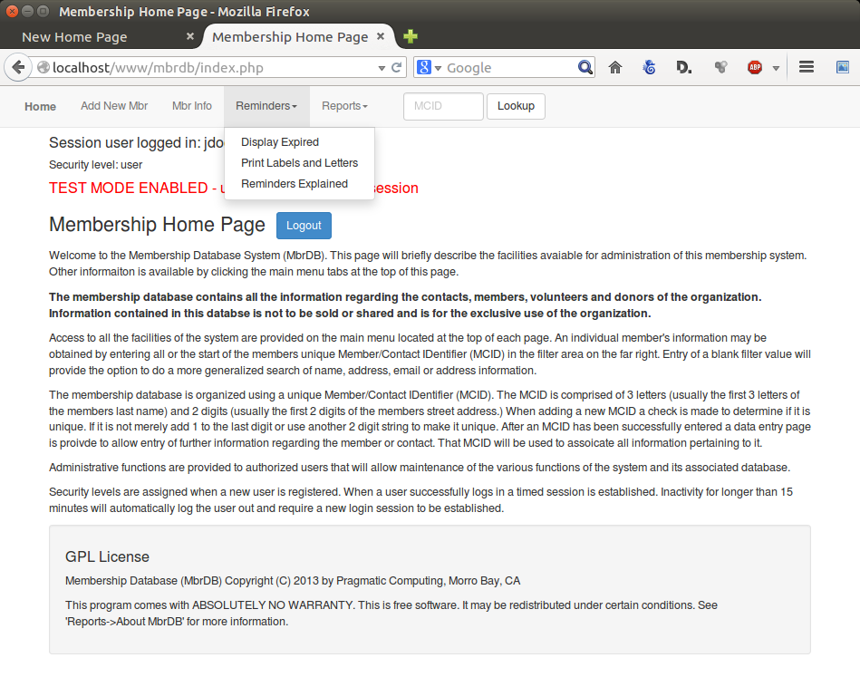

The screen shot shows the 'Reminders' drop down menu items each of which will be explained in the following paragraphs.

Display Expired

This menu item will produce a page which will list either members, volunteers or donors that do not have a 'Funding' record noted as a 'Dues' (and/or a 'Donation' for a donor) payment in the last 11 months. The page displayed allows for display of either 'members', 'volunteers', or 'donors' either with the oldest list first or the newest listed first. Each MCID is a link which will provide direct access to the information pertaining to that MCID's information, funding and correspondence records.

The following illustrates the Reminders page created.
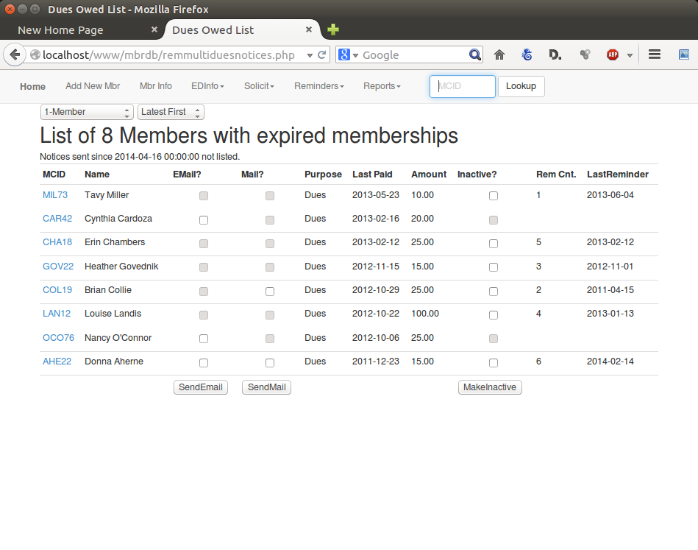
…..

Send E-mail Notice to one or more Individual MCID's

Merely click one or more listed MCID's in the 'E-mail?' column to include it in list. If the check box in the column is not 'active' (you can not create a check in it) it is indicating that the 'Email OK?' in the member record is marked as 'NO' – the supporter does not want to get email from the organization. Click the MCID link on the report to access that supporter record to review and correct if needed.

After clicking the 'Send Email' button at the bottom of the column the resulting page will allow the review of all those emails selected as well as a list of all of the e-mail templates available. After clicking the 'Submit' button, the selected templates are presented for review and modification (if needed). On final submission, the email message is automatically (and immediately) sent to the email address associated with the each selected MCIDs. As previously indicated, an entry is made in the correspondence information for the MCID noting that the email has been sent and the MCID will not appear on the 'Expired' listing for 30 days.

Development and entry of the e-mail templates is designated as an Administrator's responsibility. Instructions on the development and entry of templates is covered in the MbrDB Administrator's Guide.

Send Mail Notice to Individual MCID

This selection will initiate a process that will result in the sending of an regular mail reminder to the 'active' MCID. An entry is noted in the correspondence records for the MCID that this action has been done along with the date of the action.

A variety of mail notes may be created and sent based using predefined templates provided by the Administrator. A template message, once selected, is displayed for customization or editing prior to transmission to the email address of the currently .'active' MCID. Please note that a message length of less than 15 characters will result in name and address information for the member will be written to the print queue to produce a mailing label only.

If the MCID supporter record indicates 'Mail OK?' as 'NO' it indicates the supporter does not wish to receive mail from the organization. In this case, the check box for in the 'Mail?' column will not be selectable.

Once all MCID's have been selected the 'SendMail' button at the bottom of the column is clicked. This action writes all appropraite information to the MbrDB mail queue for printing. Additionally, an entry is noted on the correspondence log for each MCID as well as being included on the 'Display Expired' report page. The MCID will no longer be listed on the 'Expired' list for 30 days.

Print Labels and Letters

This function is provided to allow maintenance of the database queue used to hold labels and letters that are to be printed and mailed. When a mail notice is initiated, an entry is made into the letters and labels queue of the database to facilitate creation of printed labels and letters.

It should be noted that some special configuration settings must be defined in the web browser being used before labels produced can successfully be printed on label stock. Page settings for the page margins in the browser must be set at Top: 0.5, Bottom: 0.0, Left: 0.0 and Right 0.0 Specifics on how to do this varies from browser to browser but all are capable of these settings being implemented.

Also, please note that printing of labels can only be done using the Google Chrome web browser.

Once the labels and/or letters have been printed they can then be removed from the queue using the facilities provided. The date and name of when the notification was created is listed in the delete utility. Merely check those that can be deleted and click the 'Delete' button to do so.

Reminders and Notifications Explained
Reminders and notifications are utilized to maintain the enrolled membership. Membership provides an essential source of funding to support the ongoing fulfillment of the organization's mission. This function is provided to allow members to be advised when their annual membership is due.

Reminders revolve around the expired membership list that is created from the Reminders menu. A screen shot is shown above. The expired list is comprised of 'active' member records which show that no payment marked as "DUES" (or a 'Donation' in the case of a 'Donor) has been entered within the last 11 months. This would indicate that renewal reminders may need to be initiated.

It should be noted that an 'active' support is a record with a member status of '1-Member', '2-Volunteer' or '3-Donor' with the 'Mbr Inactive' flag as 'NO'. Reminders are not processed for supporters categorized as '0-Contact'.

The reminder process begins with listing all those active members for whom a payment is due. (e.g. nothing paid in the last 11 months). This listing is produced by using the 'Reminders → Display Expired' menu item. The listing produced shows all member records by default. Volunteer and Donor records are list when that option is selected from the report page drop down selection.

The listing has several columns one of which is the MCID which is a link to the member information page. Other columns contain check boxes under the headings of 'Email' and 'Mail' with submit buttons under their respective columns at the end of the listing. These check boxes are 'active' or 'disabled' depending on whether or not the member's information indicates 'Email OK?' and/or 'Mail OK?' options are enabled. If a member has indicated that they do not wish to receive email from PWC, for example, then the 'Email OK? flag is set to 'NO' and the check box on the reminder listing will be disabled. The same applies to the 'Mail OK?' flag.

Individual members are selected based on the need to send a specific reminder message to one or more in the listing. The message is chosen from list of message templates created specifically for this purpose. Email messages are sent immediately and mail messages are queued for printing. In either case, a notation is entered into the individual members 'correspondence' log that this communication has taken place.

Maintenance of the message templates is an administrative function reserved for those with the authority to develop them.

All MCID's with in-progress "renewal reminders" can be listed to provide the ability to manage membership enrollment using the 'Reports → List In-progress Reminders' report. Reminders are listed for an individual MCIDs from their correspondence logs along with the current count and date of the last reminder notice sent and are included regardless of when the reminder was sent.

A supporters MCID is no longer included in the "Expired" list when any 1 of 3 things is done:

- a payment is submitted which is entered as a new Funding record as "DUES" (or “DONATION” if a donor),
- the MCID has been re-designated to a non-Member status (Member Status of '0-Contact'), or
- the MCID has been designated as "Inactive" (Inactive flag = "YES"),.

Once a reminder message has been initiated to one or more members, they will no longer appear on the 'Expired' listing for a period of 30 days. This provides, hopefully, enough time for the member to respond. After 30 days, failing any further update, the member will again be listed on the expired report with along with the number of reminders that have been sent and the date of the last one.

A final check box column labeled 'Inactive?' is included and is active for all member's listed. This check box is to provide the ability to set one or more of these members as 'Inactive' using today's date. Usually, this option is used when it has been determined that all the notices have been sent to the member and that it is appropriate to drop the member from the database entirely. By checking one or more check boxes in the 'Inactive?' column and clicking the corresponding button at the bottom of the report will result in all those member records being marked as 'Inactive' using today's date.

It should be noted that setting a member 'Inactive' does not, in and of itself, drop the members record. The date that the 'Inactive' status has been set to is used to determine a time period of 90 days, after which the DB Janitor process will permanently delete those 'expired' supporter records along with all their associated funding, correspondence, and volunteer time entries (if any.) Any payment or donation made during that 90 day period will automatically set the member record to 'Inactive: NO' thus making the record 'active' once again.

Recommended Reminders Work Flow
To optimize the time needed to maintain expired memberships the following steps are recommended:

- Start by selecting 'Reminders → Print Labels and Letters' and delete all existing entires in the labels and letters print queue.
- Select 'Reminders → Display Expired' to list all expired members.
- Review the resulting list to make sure that either or both of the check boxes for Email or Mail are available. Update the member record(s) by clicking the MCID link to correct the email and/or mailing information to allow reminders to be sent. Re-classify or mark the member record inactive if there is no obvious method (i.e. no mailing address information or email address) to communicate with them.
- Review the listing and check all those that are candidates for sending an email reminder number one (usually those without any prior reminders.) Click the 'Send Email' button at the bottom of the column, select the appropriate email template and complete the sending process.
- Perform the previous step for each of the other for email reminders number 2 and Final using the appropriate email templates for each.
- Those remaining on the expired list will now (usually) be those that are to be mailed either a postcard or a reminder form letter.
- Check off all those to be sent a post card (usually those without any prior reminder) and click the 'Send Mail' button at the bottom of the column.
- Select the 'Reminders → Print Labels and Letters' menu item and print the labels just produced. Enter the number of 'blank' labels for a partially used first page and print these labels. Delete the printed labels when finished.
- Select 'Reminders → Display Expired' to list the remaining records. Check off all those that need to be send the reminder form letter (hopefully all those that remain) and click the 'Send Mail' button at the bottom of the column and select the appropriate template for the form letter.
- Select the 'Reminders → Print Labels and Letters' menu item to list all the queued items to be printed. Select the ''Include letterhead image in output' if the logo is to be printed.
- Finally, delete the items just printed from the 'Labels and Letters' print queue.

This process should be done periodically – usually at least weekly – to keep the database up to date. The same process should be applied to volunteers and donors as well.

Here are some import time periods to remember:
- Expiration of Inactive members for deletion from the database: 90 days.
- Expiration of Active membership period: 11 months
- Display of member on expired listing: 10 days
If a member has been marked as 'Inactive' through the reminders process, they will automatically become 'Active' again if any donation or dues payment is received prior to their deletion deadline.

Reports

A variety of reports are available to provide quick access to a variety of information from the MbrDB system. Almost all of these reports require user input and are self documented on the initial page.

It should be noted that the selection of any report from the menu will cause a new window (or browser tab) to open to display the report results. All reports have a “CLOSE' button that will close this new window. The original tab or window may also be chosen leaving the report open which is often useful when researching member information.

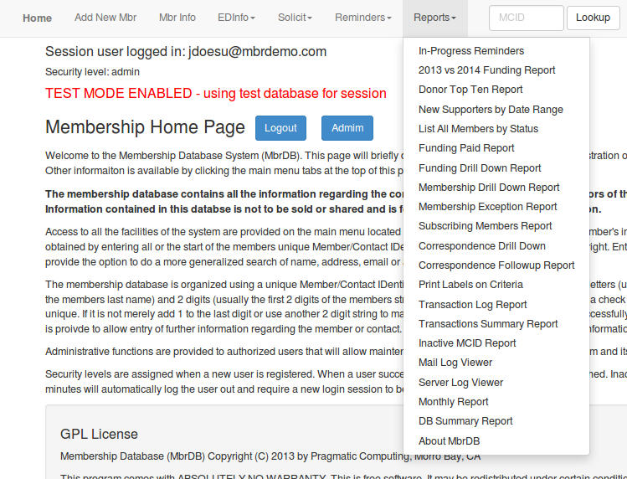
Also please note that some reports have a link that will allow downloading of the report data in CSV format to open in your favorite spreadsheet software.

The following is brief descriptions of the reports available.

List In-Progress Reminders

This menu item produces a page listing all of those MCID's for which reminders that been initiated but no funding record yet entered noted as a 'Dues' payment.

It should be noted that the MCID's listed also will appear in this report with the latest date and reminder count also noted regardless of when the reminder was sent. This report is to be able to quickly list those that are 'in-progress' for quick referral and easy access.

As a general rule, MCID's that have multiple, repeated notifications should probably be made inactive or re-classified as a 'Contact' to try and maintain some level of accuracy in MbrDB.

Top Ten Donor Report

This report provides an analysis of the funding data and provides the top ten donors in a variety of categories.

2013 vs 2014 Funding Report

Compares the total funding amounts designated as 'Dues' and 'Donations' and between 2013 and YTD 2014. The difference is shown and may qualify for matching grants.

List All Members by Status

The report opens with a selection drop down menu item displayed to select the specific membership status listing to produce the specific report.

Donor Top 10 Report

Provides a listing of the top 10 financial supporters in a variety of categories.

New Supporters by Date Range

List all supporter records whose 'Date Joined' is in the date range specified. It should be noted that these records were INTRODUCED to the database during the date range and would usually be considered as 'supporters' if any support (either financial or by volunteer time) has been provided.

List All Supporters by Status

List of all supporters by supporters status.

Funding Paid Report

This report is provided to allow selection of report details for membership funding support within a specific time period and/or a total funding range. All supporter funding records are analyzed within the period defined and a total for each MCID is displayed if the total amount is within the value range defined.

The report produced lists the total amounts funded by each MCID sorted in DECSENDING total amount order.

Funding Drill Down Report

This report provides a reporting mechanism that will allow all the different funding categories to be summarized and totaled. The report presents an drop down menu to allow selection of the various funding categories. All designated classifications within that category is displayed with another drop down menu item that allows any of them to be selected. This will produce an itemized funding record listing of all MCID's that have provided funding support in each. Funding records are listed sorted by MCID and are itemized individually.

Membership Drill Down Report

This reports provides a dynamic drill down report for all records in the MbrDB. The report presents a selection drop down to allow a choice of the membership status values available. The different membership types are then summarized and listed with the opportunity to select any one of them for a detailed listing of all members that are classified in that specific type. Details regarding each member include the MCID and name of the member. Membership records are sorted by MCID.

Membership Exception Report

Analyzes the entire database and provides an exception report based on a variety of criteria. For example, (NOTE: a section may not appear if there are no records to list.)

- 0-Contact That Paid Dues or Made A Donavon - lists all records classified as Member Status of 0 (Contacts) that have current funding records paid within the expiration period. These are suspect and should probably be reclassified.
- 1-Members or 2-Volunteers With NO Dues Payment Record - list of all records classified as 1-Member or 2-Volunteer with NO funding records paid within the expiration period.
- 3-Donors with NO Donations - list of all records classified as 3-Donor with NO donation or dues funding records paid within the expiration period.
- Invalid Mail or Email Flag Settings - list of those records that have inconsistent flag settings on the Mail and/or Email flags indicating that they want mail and/or email but there is no information provided to do so.

Subscribing Members Report

This report provides a reconciliation point for members that have been identified as 'subscribing' members where a subscribing member is defined as having a Member Status of '1-Member' with a Member Type of '1-Subscriber' or a Member Status of '2-Volunteer' with a Member Type of '2-VolSubsciber'.

This report has 3 potential sections:

- Listing of all members whose last DUES payments was marked as a 'subscription' payment but their membership status and type do not indicate them as a 'subscribing' member. These MCID's should be examined and either the payment changed to a 'regular' Purpose OR the member's record be updated to make them a 'subscribing' member or volunteer.
- Listing of all 'subscribing' members that do not have a 'subscription' DUES payment within the last 120 days. These MCID's may need to be reclassified making them 'non-subscribers' or the DUES payment deleted and re-entered as a subscription payment.
- List of scribing members with current payments made within the last 120 days with a payment that would appear to be incorrectly categorized. This payment(s) may need to be reclassified by deleting the DUES payment and re-entering it as a subscription payment.
- Listing of all MCID's that are registered as 'subscribing' members that have a DUES payment designated as a 'subscription' payment within the last 120 days.

NOTE: the first three sections will not appear unless there is a qualifying MCID to be listed.

Correspondence Drill Down Report

This report provides the ability to list and detail the various correspondence categories that are currently in the correspondence log of the database. The categories are configured in by the administrator as correspondence categories. Each category should specify a type of correspondence used to communicate with the member. Some category values are historical and have been retained from prior systems and may be seen depending on the date range defined.

Correspondence Follow-Up Report

This report provides the ability to list those members who have paid dues but have not had any follow up correspondence sent to them.

This report creates a list of the dates all member correspondence records that contain 'RenewalPaid' in the Correspondence Type field. If there is any correspondence noted AFTER that date for the member, the record is dropped from the list. All those remaining are reported in the resulting lists.

NOTE: This listing does NOT include subscribing members.

A member's MCID being in this list means that there probably should be a follow up note sent to the member acknowledging the dues payment.

Print Labels on Criteria

This 'report' will produce label output formatted for direct printing onto label stock. Selection criteria include selecting records based on membership status, date range for funding paid, and/or date range for the total funding provided.

It should be noted that use of the Google Chrome browser is required and that some special configuration settings must be defined in the web browser before labels produced can successfully be printed on label stock. Page settings for the page margins in the browser must be set at Top: 0.5, Bottom: 0.0, Left: 0.0 and Right 0.0.

Transaction Log Report

This report provides chronological audit trail of all funding records entered within a specific date range. It is intended that this provide oversight to the data entry of these records to ensure accuracy and timeliness. This report is often used to cross audit funding received with the financial system of record. Download of all transactions in CSV format is provided.

DB Summary Report

This report provides an analysis of the entire database giving a variety of information. This report is provided to allow an overview of the database from a variety of perspectives.

About MbrDB

This modal provides licensing information as well as links to various support documentation (such as this document.)

Ad Hoc Reports

It is strongly recommended that ad hoc reporting be performed using LibreOffice. Specific information about how to use LibreOffice and its 'Base' functionality is beyond the scope of this document.

LibreOffice Base can be used to configure the MbrDB database as an external data source. Once successfully done, ad hoc queries, reports, and spreadsheets may all be extracted easily on an on demand basis.

Specifics on the database names, user login names and passwords will vary and need to be coordinated with the system administrator to successfully accomplish this.

Funding Categories
Tracking and analysis of funding sources is important information to understand the level of support being provided by members, donors and fund raising efforts. Proper management of this allows an organization to assess the efficacy of programs and campaigns and direct resources to those that are successful.

The MbrDB system provides 3 classifications on the funding record that allows categorization of all funds received. These classifications are coupled with a variety of automatic reports that allow reporting of all funding sources.

The following grid shows the relationship between the categories of 'Purpose' and 'Program' that have been defined as defaults for the system. These two, coupled with a third category of 'Campaign' allows the organization to track and report on funding.

All three categories are configurable by the System Administrator. Changes to any of these should be carefully considered before being implemented. These relationships are enforced by page level validations to ensure that correct entries are specified by the entry person. Any changes should keep the relationship of the first three characters of the db notation for the 'Purpose' with the first three characters of the db notation for the Program. This will provide accuracy when data is entered or updated into a funding record.

Purpose | DB Notation
  Program | DB Notation
Dues | Dues
  Annual Membership | dues-AnnualMbr
  Subscribing Membership | dues-Subscr
  Other Dues (please note) | dues-Other
Donation | Donation
  Unrestricted Donation | don-UnresDonation
  In Memorandum | don-IMO
  In Honor Of | don-IHO
  Other Don.(please note) | don-Other
Directed Donation | DirDon
  Directed Don. Funding | dir-DirDonFunding
  Other DirDon(please note) | dir-Other
In-Kind Donation | InkindDon
  In-kind (Facility) | ink-Facility
  In-kind (Food/Medication) | ink-FoodMeds
  Other In-Kind(please note) | ink-Other
Grant | Grant
  Grant Funding | gra-GrantFunding
Fund Raising | FundRaising
  Event | fun-Event
  Event Donation | fun-Donation
  Other Fund Rsr(please note) | fun-Other
Program Income | PrgIncome
  Sales (t-shirts, etc.) | prg-Sales
  Eduction Presentation | prg-EducPres
  Exclusion Program | prg-ExclProg
  Deposit | prg-Deposit
  Other Prog Incm | prg-Other

Purposes

In general, the category 'Purpose' is used to identify the reason that the funds have been provided to the organization. They constitute the most broad generalization of the source of fund income that any organization receives. Any new items added to this list should be considered from the perspective of the organization. If a new 'Purpose' is to be added, then it should be with a view to understanding what reporting results are trying to be accomplished and the definition of two or more associated 'Programs'.

Page validations require that each funding record be provided with a 'Purpose' and associated 'Program' before allowing the funding record to be entered or updated. Additionally, if any 'Program' is entered as “Other', the 'Notes' field of the record must contain a description of the funding being recorded.

The 'Funding Drill Down Report' provides a mechanism to summarize all 'Purposes' defined providing a funding record count and total amount for each within a specified date range.

Programs

The 'Programs' category is used to further identify the intended source of the funds received. Reporting will provide a listing of all programs defined along with the total number of funding records associated plus a total amount for each 'Program'. The “Drill Down' summary will also provide details of all funding records associated with each.

Page validations require that each funding record be provided with a 'Purpose' and associated 'Program' before allowing the funding record to be entered or updated. Additionally, if any 'Program' is entered as “Other', the 'Notes' field of the record must contain a description of the funding being recorded.

The 'Funding Drill Down Report' provides a mechanism to summarize all 'Purposes' defined providing a funding record count and total amount for each within a specified date range.

Campaigns

The following are the items currently defined for the 'Campaign' category. Obviously more will be necessarily added as new event and campaigns are undertaken.

The 'Funding Drill Down Report' provides a mechanism to summarize all 'Campaigns' defined providing a funding record count and total amount for each within a specified date range.

Newsletter | Newsletter
End of Year Appeal | EOYAppeal
Fund Our Vet | FundOurVet
Radio/TV/News article | Media

Implementation Notes
MbrDB is a membership management system designed for use by non-profit organizations needing a database solution to organize and optimize their supporter community.

This program is free software: it can redistributed and/or modified under the terms of the GNU General Public License as published by the Free Software Foundation, either version 3 of the License, or (at your option) any later version.

This program is distributed in the hope that it will be useful, but WITHOUT ANY WARRANTY; without even the implied warranty of MERCHANTABILITY or FITNESS FOR A PARTICULAR PURPOSE. See the GNU General Public License at http://www.gnu.org/licenses/gpl.html for more details.

Technical requirements:
- An Internet Service Provider (ISP) must be used.
- Access to the ISP via FTP must be supported and provided to the installation team.
- The ISP must be able to provide PHP, mySQL5 and phpMyAdmin software functionality required by MbrDB.
- Tech support numbers for the ISP must be acquired and provided.

Organizational requirements:
- One or more technical 'savvy' person(s) from the non-profit must be appointed to be the responsible party(s) to assume responsibility for the system after installation and acceptance.
- Installation includes upload of all applicable software onto the target ISP system and successful testing using the test and validation database.
- Support for initial installation and implementation will be provided for 10 hours FREE.
- Conversion support for existing data is included in the installation time.
- All additional time beyond 10 hours required for installation and/or customization will be provided on a quote only basis at a base hourly rate of $150 per hour. These services require a special detailed work order specifying the work products and outcomes jointly agreed and signed by both parties.

